Introduction

Installation
Need to install IUP binaries and GTK libraries. IUP binaries can be found at
http://sourveforge.net/projects/iup/files

There is an installation script called install which needs to be run as sudo or the installation will fail. It installs the Run Time libraries of IUP

This program also requires GTK 2.0, Gdk, Pango and Glib

sudo apt-get install cairo
sudo apt-get install gtk+2.0
sudo apt-get install libpango
sudo apt-get install

Hello World

import cg. 1
main => 2
Hello = new_text_box(), 3
Hello.text = ‘hello world’, 4
show(Hello). 5
Our Hello World program starts by importing the graphics module cg in line 1. Line 2 creates a program named main which is defined by the code in lines 3 to 5. On line 3 new_text_box() creates a new text object which is assigned to the variable Hello. Initially no words are written in this text box. The words Hello World are set to the string in line 4 by using the text attribute of the text box object.

We need to compile and run this program. We can load the program when opening Picat by adding the name of the file to the command line when opening Picat. Alternatively the program can be manually compiled and run inside Picat. Once we have started running Picat, compilation is done by typing cl(hello) if the file name is hello.pi. To run the program we need to call on the main function, by simply typing main after the compilation finished. When hello program is displayed the following image should be displayed:
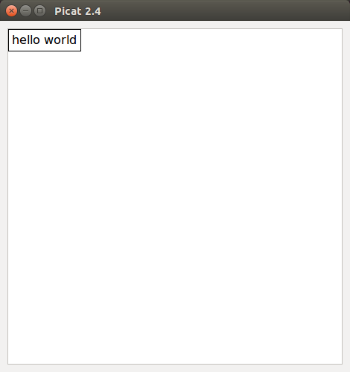
Figure 1: Hello World Program

First you need to create some objects. If no other specifications are given, all objects except polygon, triangle and line will find default values for size and location. The objects default location is the upper left corner, which corresponds to the origin, with an x-coordinate and y-coordinate of 0. Objects can be resized or moved by creating some constraints using their attributes. For example the x and y attributes set the horizontal and vertical starting point value of the object. Objects are drawn below the x value and to the right of the y value.

Once any desired constraints are specified, the object can be displayed with the show(O),where O is the objects or list of objects you wish to display. Objects at the beginning of the list will be drawn first and may be covered by objects drawn after. So show([new_circle(),new_square()]) will display a square object on top of a circle object, as the default location of the two objects overlap.
The graphical library has the following objects:
Arc
Circle
Label
Line
Oval
Polygon
Rectangle
Square
Star
Text box
Triangle
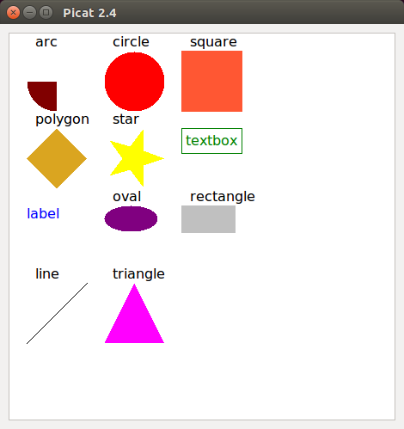
Figure 2: Objects that can be displayed
Components and Attributes
All objects have some quantity of attributes that describe how they look. All attributes have some type with only certain values accepts. For example x, y, width and height are all integer values between 0 and 1000, while the fill attribute of circle, rectangle, and triangle only accepts integer values of 0 or 1. If the value of an attribute is not specified by the program, default values provided by cg will be selected and used. For example, width and height have a default of 20, while x and y default to 0.
Attributes can be accessed by dot notation, so an attribute attr of an object O is accessed by O.attr. Attributes may be assigned values by a constraint as in the Hello.text #= ‘Hello World’ of the Hello World example program.
All the objects are based around a shared component which determines some of the basic location, size, and color of the object. If specific values are not given for these attributes when show() is called, values will be selected except for in the objects of Triangle, Polygon and Line. Some of the attributes of the object will be stored explicitly and others will be calculated from the stored values.

The following attributes are base attributes and stored explicitly:
x - the horizontal starting position measured in pixels from the left hand corner. Default value of 0
y - the vertical starting position measured in pixels from the top of the canvas. Default value of 0
width - the width of the object, so the end of the component is x+width pixels from the left. Default value of 20 for all objects except Triangle, Polygon, and Line
height - the height of the object. The end of the component will be at y+height pixels below the top of the canvas. Default value of 20 for all objects except Triangle, Polygon, and Line which do not have default values
color - the color of the object, currently the supported colors are
dark red, red, orange, salmon, yellow, gold, lime, green, cyan, blue, purple, pink, white, silver, gray and black
The default color is black.

Colors
The rgb of the colors are as follows:
dark red - (128, 0, 0)
red - (255, 0, 0)
orange - (255, 87, 51)
salmon - (250,128,144)
yellow - (255,255, 0)
gold - (218,165, 32)
green - ( 0,128, 0)
lime - ( 0,255, 0)
cyan - ( 0,255,255)
blue - ( 0, 0,255)
purple - (128, 0,128)
pink - (255, 87, 51)
white - (255,255,255)
silver - (192,192,192)
gray - (128,128,128)
black - ( 0, 0, 0)

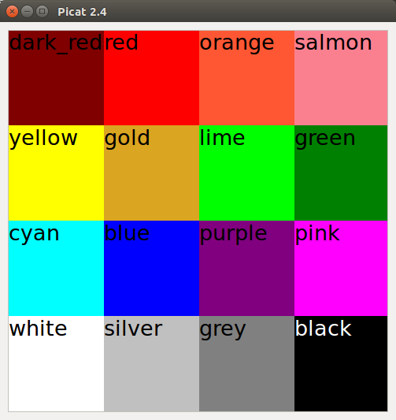
Figure 4: Colors in Picat

Derived attributes are created from the base attributes by creating one or several constraints for their locations behind the scenes. For example we will look at how centerX is calculated. When the centerX attribute is accessed the system replaces the attribute with a variable and add a constraint to calculate the variable from the base attributes.
O.centerX #< 50,
Is internally changed in the following way
O.centerX #= V,
V #= O.x + O.width//2,

The following derived attributes are calculated from base attributes:

centerX - the center horizontal location of the component
Applies the following constraints: O.centerX #= O.x + O.width//2,
centerY - the center vertical location of the component
Applies the following constraints: O.centerY #= O.y + O.height//2,
rightX - the rightmost dimension of the component. Note there is no leftX value as it will have the same value as the base attribute x
Applies the following constraints: O.rightX #= O.x + O.width,
bottomY - the lowermost dimension of the component. There is no topY as the base attribute y has the same value
Applies the following constraints: O.bottomY #= O.y + O.height,
leftTopPoint - point at the upper left side
rightTopPoint - point at the upper right side
Applies the following constraints: O.rightTopPoint #= P,
P.x #= O.x + O.width,
P.y #= O.y,
leftBottomPoint - point at the lower left side
Applies the following constraints: O.leftBottomPoint #= P,
P.x #= O.x,
P.y #= O.y + O.height,
rightBottomPoint - point at the lower right side
Applies the following constraints: O.rightBottomPoint #= P,
P.x #= O.x + O.width,
P.y #= O.y + O.height,
centerPoint - located in the center of the component
Applies the following constraints: O.centerPoint #= P,
P.x #= centerX,
P.y #= centerY,
Different objects have additional attributes, such as text having a font attribute which sets the font for that object. Both component attributes and the ones specific to the object for each object can be accessed with dot notation.
Arc
Arc is a portion of a circle. A graphical object of type Arc is created with
O = new_arc(),
Attributes:
fill - Filled if 1 and hollow if 0. Default value of 1
startAngle - the starting angle of the arc in degrees. Accepts integer values between 0 and 360. The angles lie on a coordinate system with an origin of the center of the arc
arcAngle - how far the arc continues in degrees. Accepts integer values between 0 and 360. An arcAngle of 360 degrees will be a full circle, 180 a half circle starting at the startAngle
An unfilled arc with a startAngle of 0 and arcAngle of 360 will be a hollow circle.
A filled arc with a startAngle of 180 and an arcAngle of 360 will be the solid bottom half of a circle.

Circle
A graphical object of type circle is created with:
O = new_circle(),
Attributes:
fill - A solid filled-in circle if 1 and a hollow circle if 0. Default of 1
diameter - The diameter of the circle. Must be a positive integer
Creating a circle also creates an additional constraint that the width and height must be equal.
O.width #= O.height,
If this is not desired use the Oval object, which allows different values for width and height.
Label
A graphical object of type Label is created with:
O = new_label(),
Attributes:
text - the words to be written. Can either be a single word with no spaces such as O.text #= hello, or one or more words surrounded by single quotes O.text #= ‘hello world’,
font - the font of the text. Accepted values are courier, helvetica, times, or system. Defaults to system
font_size - the size of the font. Accepts integer values between 1 and 100. Defaults to size 12
font_style - the style of the font. Accepts values bold, italic or plain. Defaults to plain
Label has an internal calculation of the size of the text based on the font, font_size and font_style attributes.

align - where the text box is drawn in relation to the x and y values of the component. Possible alignment values are left, right and center. Defaults to left

Line
A graphical object of type Line is created with:
O = new_line(),
Attributes
x1 - the x-coordinate of the starting point. Non-negative integer values accepted. Defaults to 0
x2 - the x-coordinate of the ending point. Non-negative integer values accepted. Defaults to 0
y1 - the y-coordinate of the starting point. Non-negative integer values accepted. Defaults to 0
y2 - the y-coordinate of the ending point. Non-negative integer values accepted. Defaults to 0
point1 - the first point in the line, an alternative way to assign x1 and y1
point2 - the second point in the line, an alternative way to assign x2 and y2

If no values are given for the attributes, x1, x2, y1, and y2 will all be set to 0, so no line will be drawn
x1, x2, y1 and y2 can also be accessed by the point1 and point2 attributes. point1 is [x1,y1] and point2 is [x2,yx]. As such x1 can also be accessed by point1[1]
Line has constraints to ensure that the locations of the points cannot exceed the location specified by the x, y, width and height attributes if any are assigned. For example if you make the following constraints:

L= new_line(),
L.x #= 0,
L.y #= 0,
L.width #=100,
L.height #= 100,

The location of x1, y1, x2, and y2 must all be values between 0 and 100.

This is done by additional constraints in the initiation of the object that ensure the x of the component must be less than or equal to the values for x1 and x2 and that rightX is greater than or equal to x1 and x2. Similarly constraint are added ensuring y of the component must be less than or equal to the values of y1 and y2 and that bottomY must be greater than or equal to y1 and y2.
In lines the component attributes of x, y, width and height will not be assigned if not set by user.

Oval
A graphical object of type Oval is created with:
O = new_oval(),
Attributes:
fill - A solid filled-in circle if 1 and a hollow circle if 0. Default of 1
Polygon
A graphical object of type Polygon is created with:
O = new_polygon(N),
where N is the number of points in the polygon.
Attributes:
fill - a filled polygon if 1, a hollow polygon if 0. Default value of 1
xs - the x-coordinates of the points in the polygon. Must be in a list of length N
ys - the y-coordinates of the points in the polygon. Must be in a list of length N
If the length of xs and ys are not equal to N, the constraint solver fail and return no. If xs or ys are not set by the user, they will be set to a list of zeros of length N, therefore nothing will be displayed. The component attributes of x, y, width and height will not be assigned if not set by user in polygon objects.

Rectangle
A graphical object of type rectangle is created with:
O = new_rectangle(),
Attributes:
fill - a solid rectangle if 1, a hollow rectangle if 0. Default value of 1
Star
A new star object is created with:
O = new_star(N),
Where N is the number of points on the star.
Attributes:
N - the number of points on the star. Can only be assigned in the function new_star(N)
angle0 - integer values between 0 and 360. A value of 0 will have the first point of the star aligned with a y-axis starting at the center of the star. Other values will rotate the star so that the starting point will make an angle of angle0 degrees from the y-axis
fill - a solid star if 1, or a hollow star if 0. Default value of 1

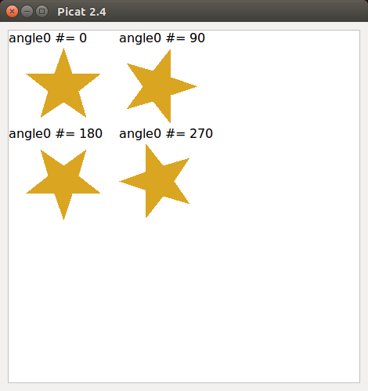
Figure 5: angle0 of a five-pointed star
Square
A graphical object of type Square is created with:
O = new_square(),
Attributes:
fill - a solid square if 1, a hollow square if 0. Default value of 1
Square enforces the constraint that the width and the height of the object must be equal. If this is not desired use rectangle.

Text Box
A graphical object of type Text Box is created with:
O = new_text_box(),
Attributes:
align - where the text box is drawn in relation to the x and y values of the component. Possible alignment values are left, right, and center. Defaults to left
text - the words to be written. Can either be a single word with no spaces such as O.text #= hello, or one or more words surrounded by single quotes O.text #= ‘hello world’,
font - the font of the text. Accepted values are courier, helvatica, times, or system. Defaults to system
font_size - the size of the font. Accepts integer values between 1 and 100. Defaults to size 12
font_style - the style of the font. Accepts values bold, italic or plain. Defaults to plain
padding - the spacing between the edges of the text box and the text inside. Must be an integer between 0 and 100. Defaults to 5
Text Box has an internal calculation of the size of the text based on the font, font_size, font_style and padding attributes.
Triangle
A graphical object of type Triangle is created with:
O = new_triangle()
Attributes:
fill - a solid triangle if 1, a hollow triangle if 0. Defaults to 1
x1 - the x-coordinate of the first point of the triangle
x2 - the x-coordinate of the second point of the triangle
x3 - the x-coordinate of the third point of the triangle
y1 - the y-coordinate of the first point of the triangle
y2 - the y-coordinate of the second point of the triangle
y3 - the y-coordinate of the third point of the triangle
point1 - the first point in the triangle. Equivalent to [x1,y1]
point2 - the second point in the triangle. Equivalent to [x2,y2]
point3 - the third point in the triangle. Equivalent to [x3,y3]
Assigning triangle by points
import cg.
main =>
Tri = new_triangle(),
Sq = new_square(),
Tri.point1 #= Sq.leftTopPoint,
Tri.point2 #= Sq.rightTopPoint,
Tri.point3 #= Sq.leftBottomPoint,
show(Tri).
Similar to Line and Polygon, if the points of a Triangle object are not assigned, they will be set to 0.

Displaying Objects
Objects that have been created are shown with a call to show(). show() must be sent a single object or a list of objects ordered in the order in which they will be drawn. show() can be called multiple times, each time only displaying the objects sent to it. If an object has previously been shown, it will still maintain its attributes.

Constraints
The cg module uses a constraint-based solver for selecting the location of components. Specifications of the attributes enforces constraints on the solution.
So far we have only looked at simple equality constraints #=, however several other options exist for creating constraints. These are
#!= Not equal
#< Less than
#> Greater than
#<= Less than or equal to
#>= Greater than or equal to

Grid

Grid automatically assigns locations so that the objects are laid out in a grid pattern. To specify the shape of the grid, use a nested lists or array. For example a 2x3 grid of objects `O1` to `O6` is assigned by:

grid([[O1,O2],
[O3,O4],
[O5,O6]]),

Grid also allows the user to specify a certain amount of spacing between the objects, by giving two integer values after the matrix, which must be equal to each other.

grid([[O1,O2],
[O3,O4],
[O5,O6]], 10, 10),
With grid() it is not necessary to show all the objects that have been created. For example, in grid, you may need to create extra components to handle blank spaces in between objects. If you do not wish objects displayed simply do not add them to the list that is sent to show.
import cg.
main =>
Show =[Show1,Show2,Show3,Show4,Show5],
Extra = [Extra1,Extra2,Extra3,Extra4],
foreach (I in Show)
I = new_rectangle()
end,
foreach (J in Extra)
J = new_circle()
end,
grid([[Show1, Extra1, Show2],
[Extra2, Show3, Extra3],
[Show4, Extra4, Show5]]),
show(Show).
In this example, only Show1-5 will be drawn and the pattern will look like Figure 1 if no other constraints are given.
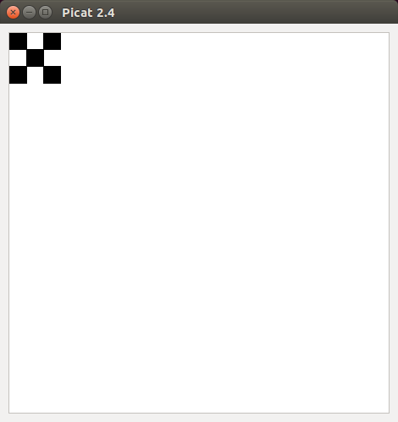
Figure 1: Grid of squares with black spaces
Tree

The tree() function creates visualizations of tree-like relationships. A tree is composed of nodes, which have an object and a list of their children objects.

The function signature for tree is as follows:

tree(Tree,Type,DisX,DisY,Centered)

Tree - the nodes of the tree, where each node is of the form node(Object, Children) where Object is the graphical component of the node and Children is a list of sub-tree in the same form as Tree. Children can have any number of nodes within it The simplest possible Tree is node(Object, [])

Type - determines the direction the tree is drawn. Can be one of the following:
top_down
left_right
bottom_up
right_left

DisX - the horizontal distance between each object. If top-down or bottom-up it is the distance between the nodes on a single layer. If left-right or right-left, it specifies the distance between a parent node and its children nodes

DisY - the vertical distance between each object. If left-right or right-left it is the distance between the nodes on a single layer. If top-down or bottom-up, it specifies the distance between a parent node and its children nodes

Centered – How the nodes are organized. Can be either centered or itemized. centered places the nodes centered below its parent node. itemized places adds a slight indent for each layer, so that each node on the same level has the same indent

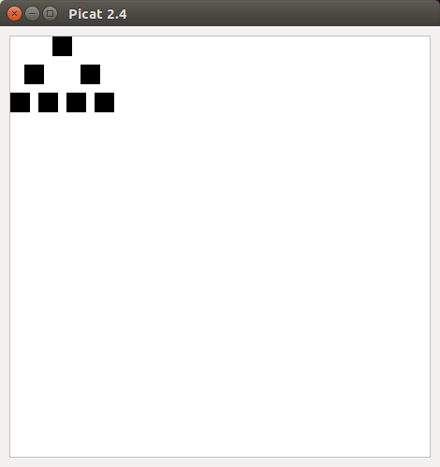  top_down centered | 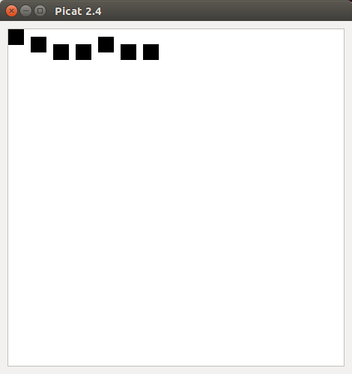  top_down itemized | 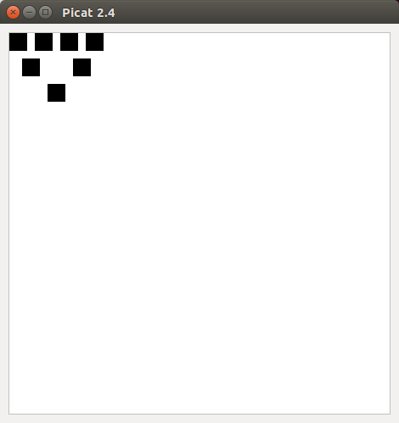  bottom-up centered | 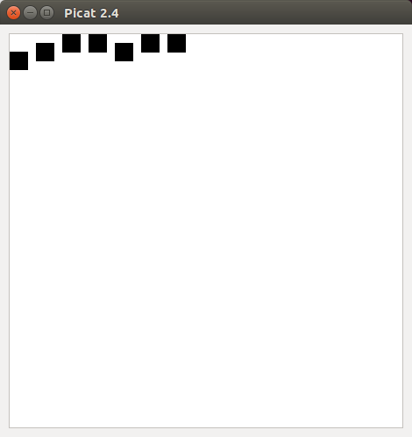  Bottom-up itemized
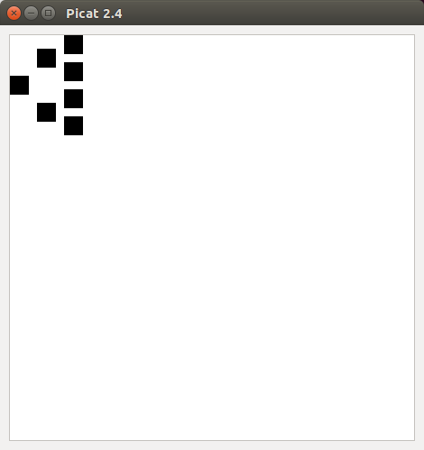  Left-right centered | 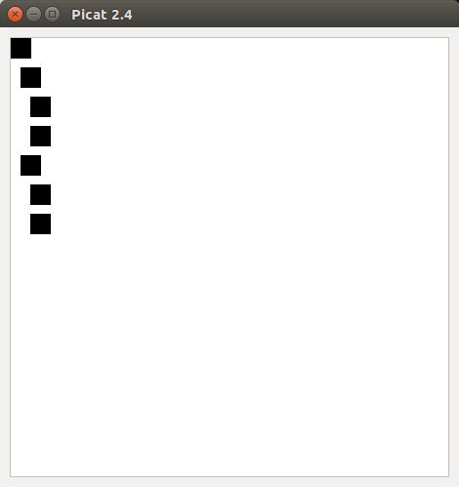  Left-right itemized | 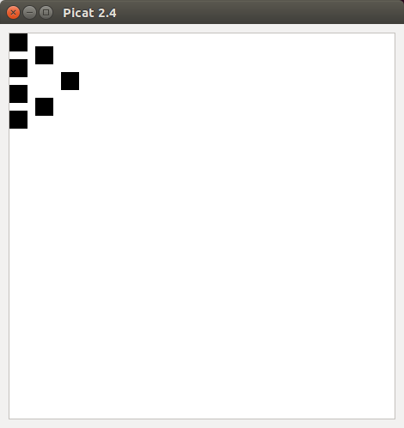  right_left centered | 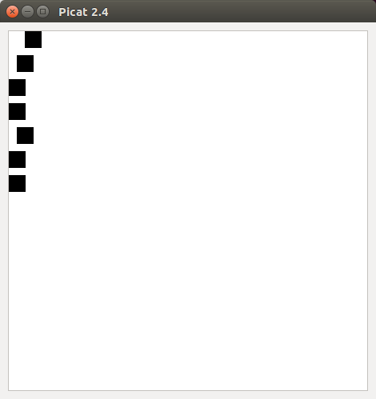  right_left itemized
Figure 6 – Different visualizations of tree structures

Example tree program without recursion:

import cg.

main =>
node(C),
node(L),
node(R),
L1 = new_line(),
L2 = new_line(),
Lines = [L1,L2],
L1.point1 #= C.centerPoint,
L2.point1 #= C.centerPoint,
L1.point2 #= L.centerPoint,
L2.point2 #= R.centerPoint,
Tree = $node(C,[$node(L,[]),$node(R,[])]),
tree(Tree,top_down,0,4,centered),
show([C,L,R|Lines]).

node(C) =>
C = new_circle().

